Week 6 Assignment

By

Ujjwal Bhasin - 200389272

Relational Databases

Prof. Maziar Shajiri

1. Add ‘Bonus’ as the second column to your table. If customers have MasterCard the Bonus will be 100.00, and if they are using Visa the bonus will be 75.00. If they are using any other credit cards the bonus have to be zero.

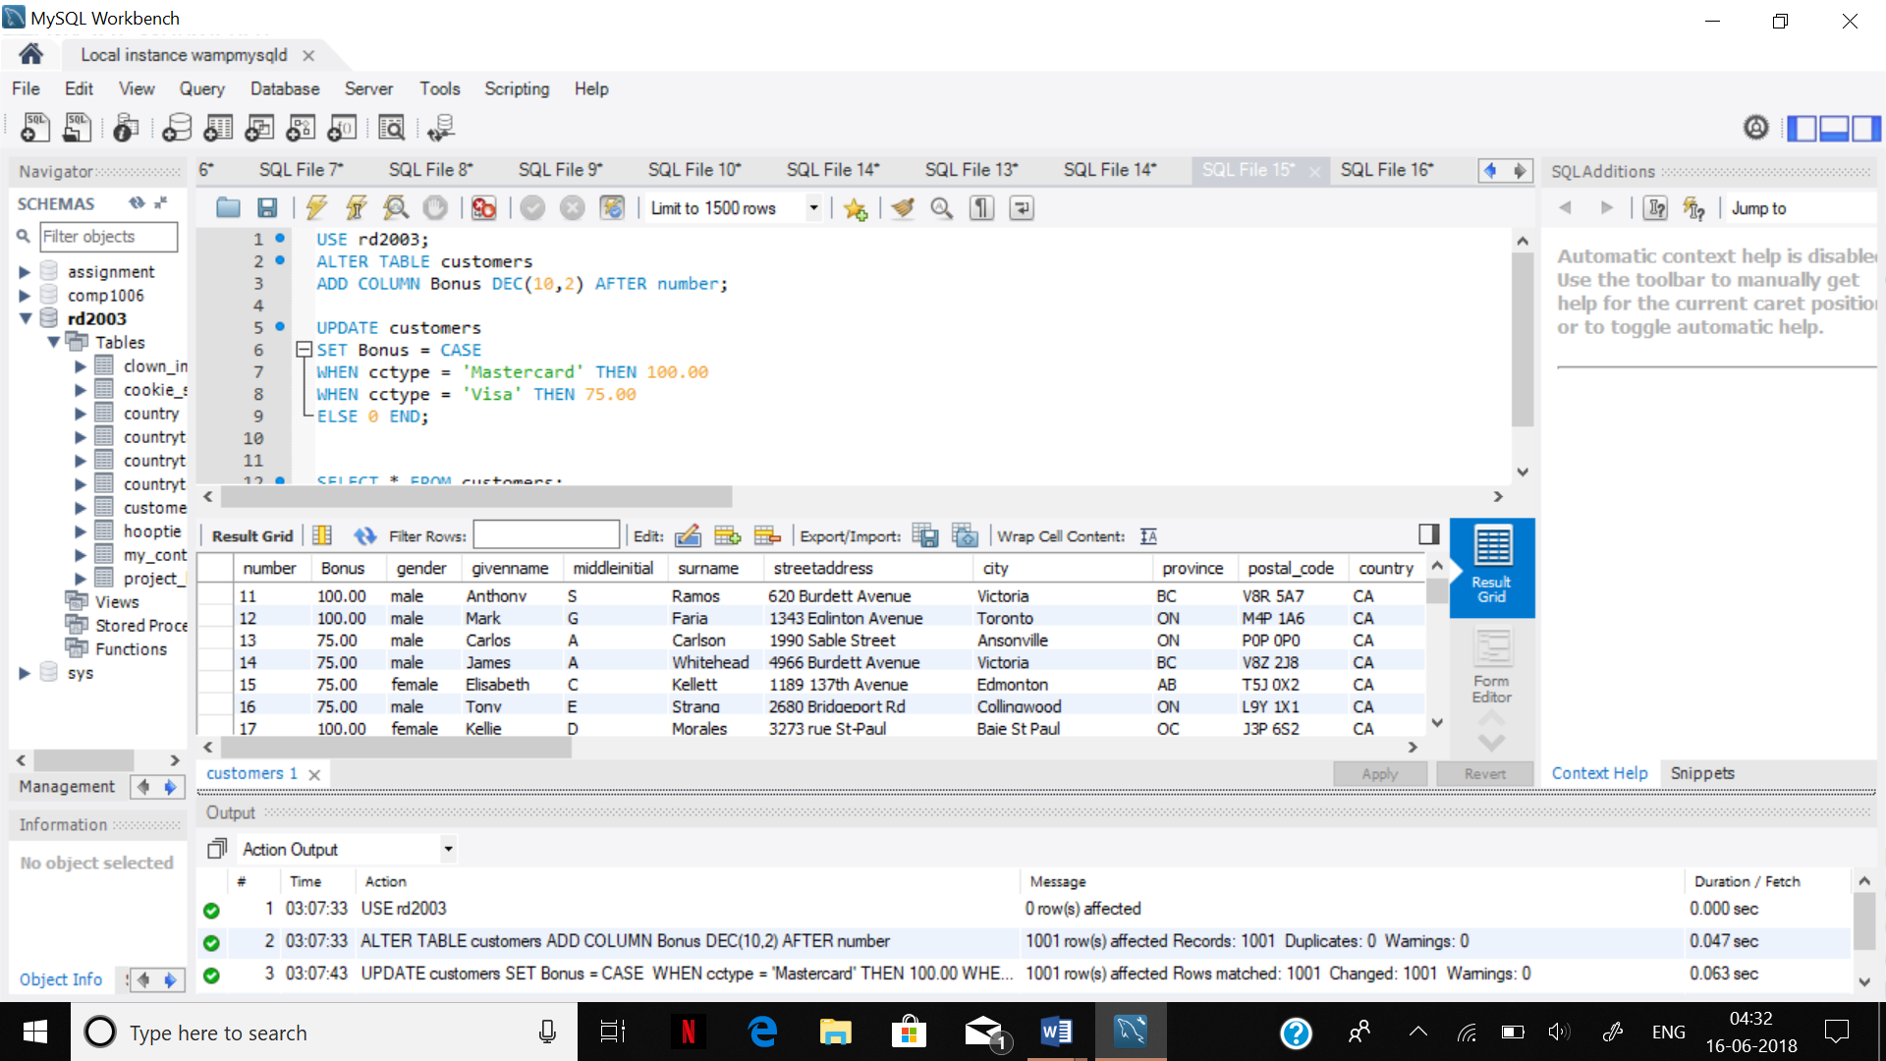

2. We need to see all customer names (surnames) starting with ‘H’ with their IDs and bonuses. Sort the names alphabetically.

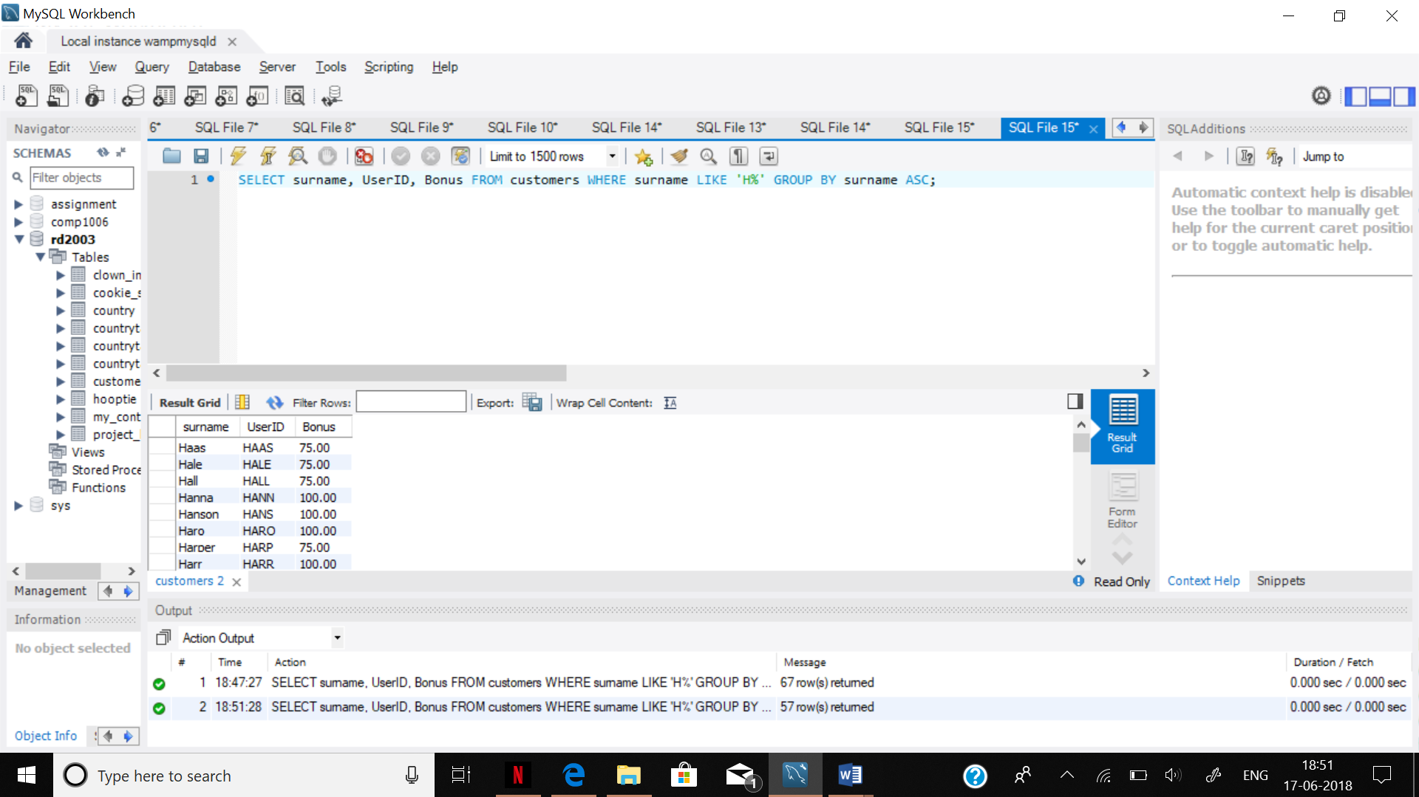

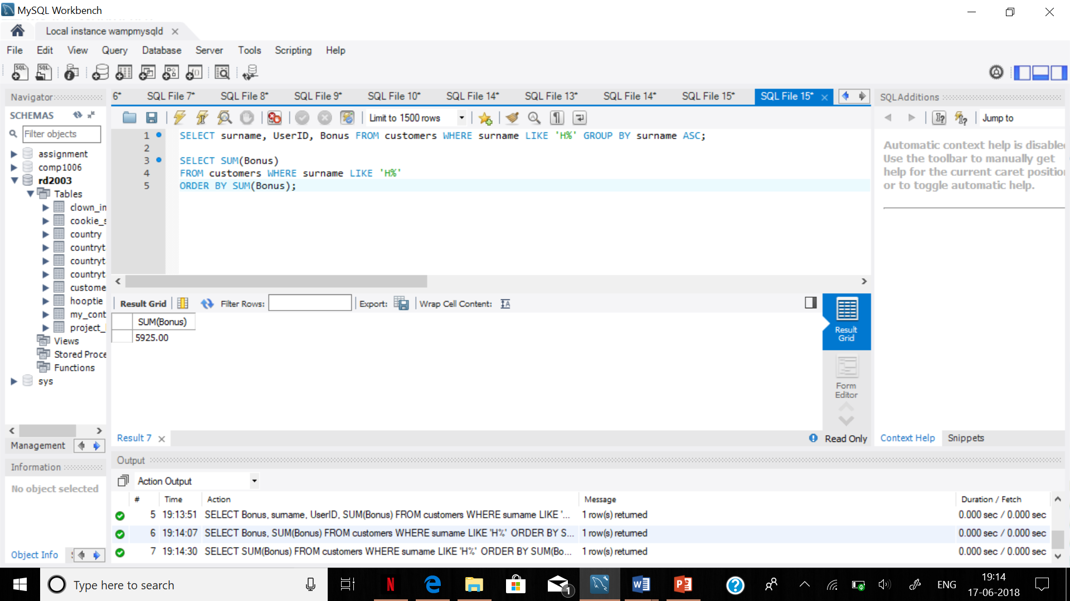

3. Write a query to calculate and present the sum of amounts of bonuses of Visa and MasterCard holders.

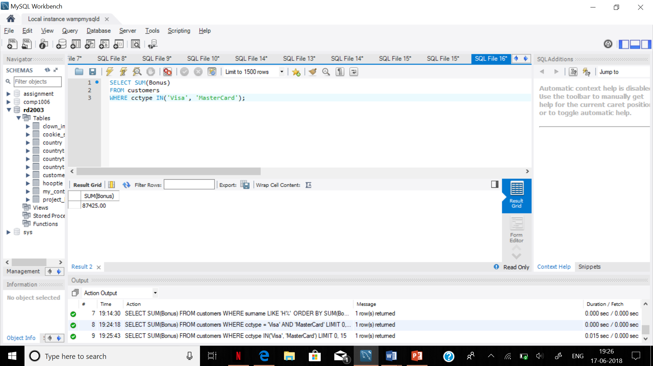

4. - Write a query to show how many users have MasterCard and how many are using Visa cards.

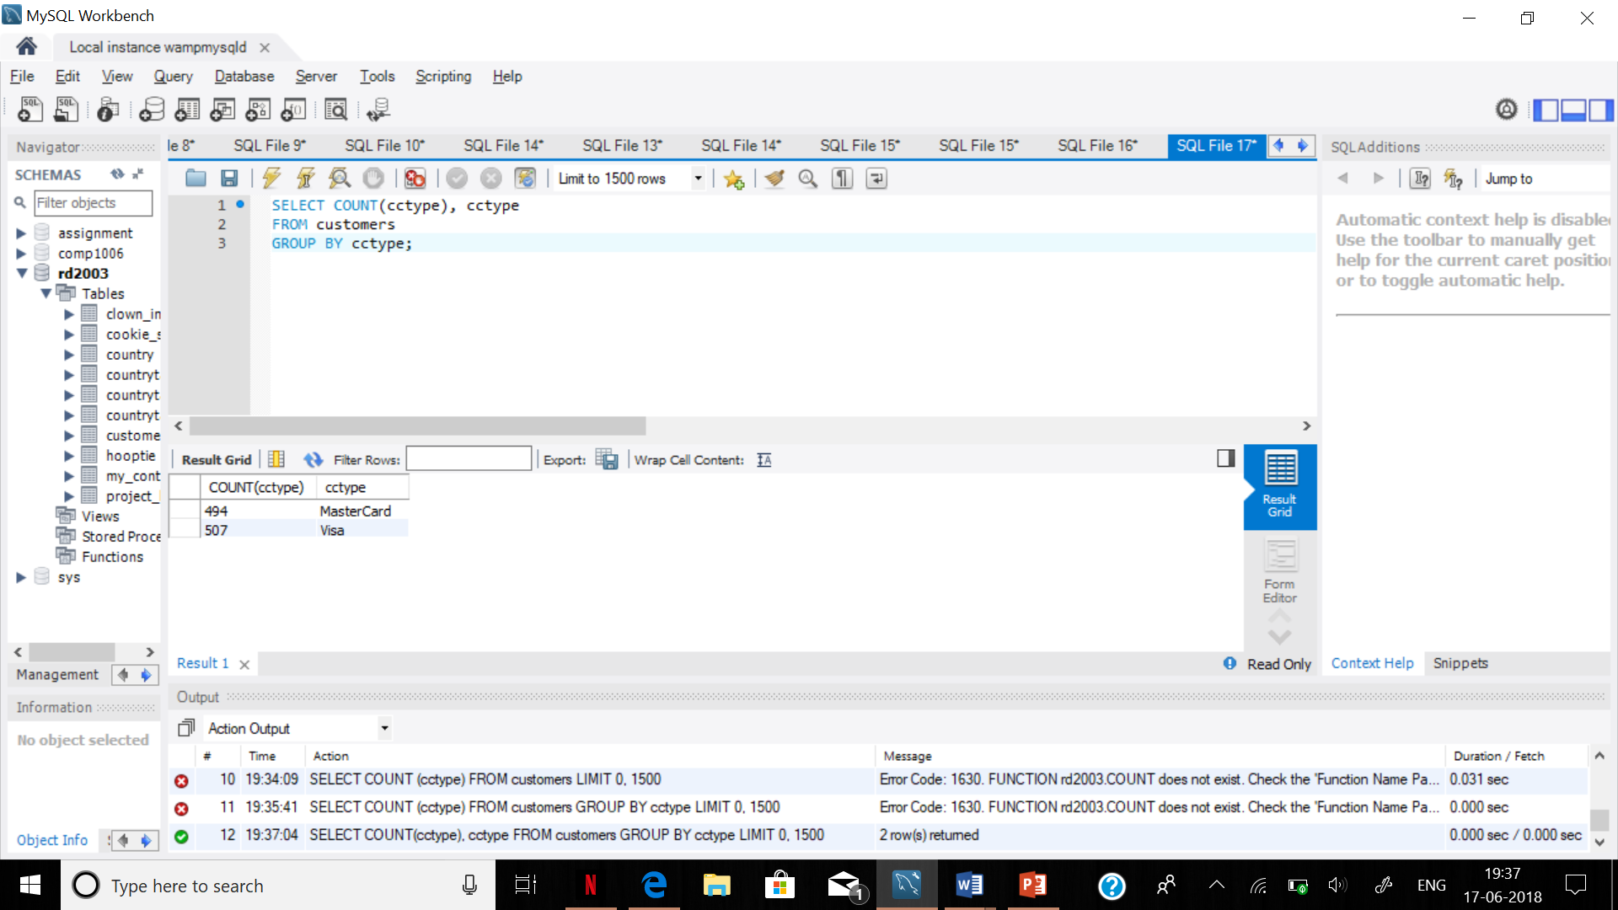

5. How many names (givenname) are in customer’s table?

